Econometric Research Association Data Analytics and Machine Learning International Conference
DATAMACLEA’24
June 28, 2024
Registration
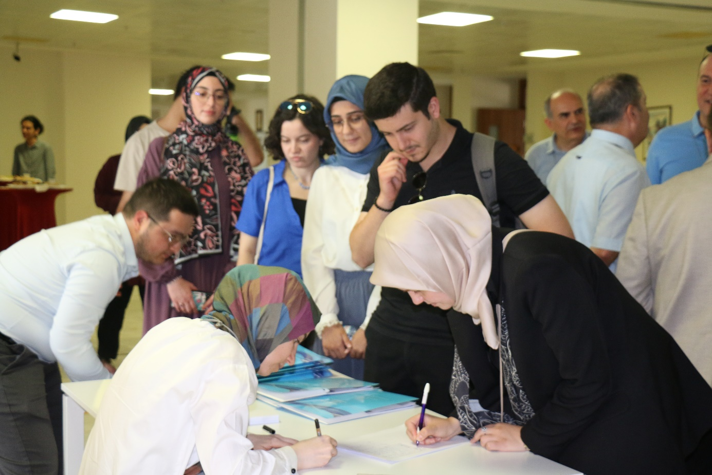

Opening Speaches
Assoc. Prof. Dr. Sıdıka BAŞÇI – Founder and Manager of Econometric Research Association and Assoc. Prof. Dr. at Ankara Yıldırım Beyazıt University
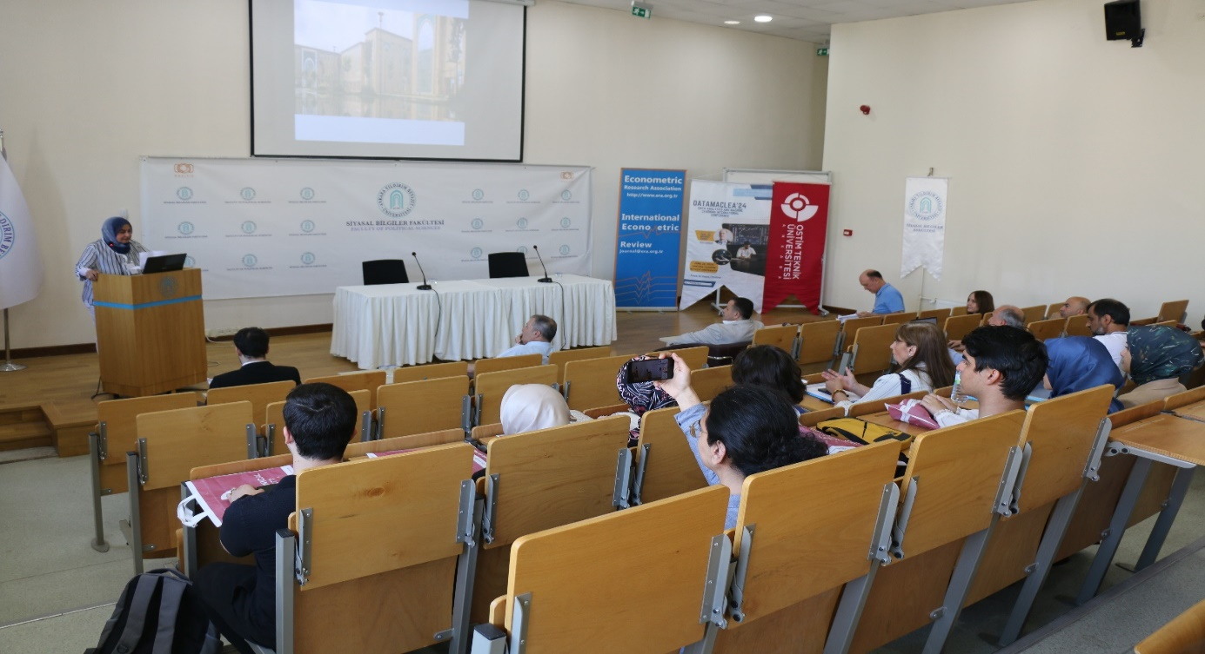

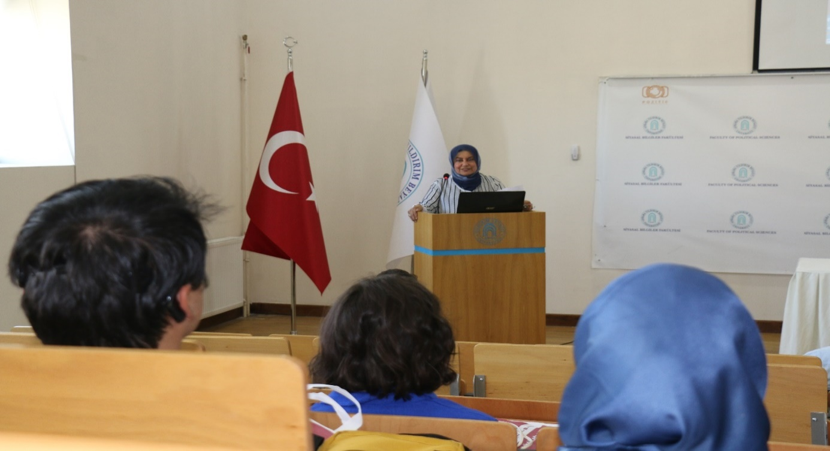

Prof. Dr. Murat ASLAN – Chair of Department of Economics at Ankara Yıldırım Beyazıt University
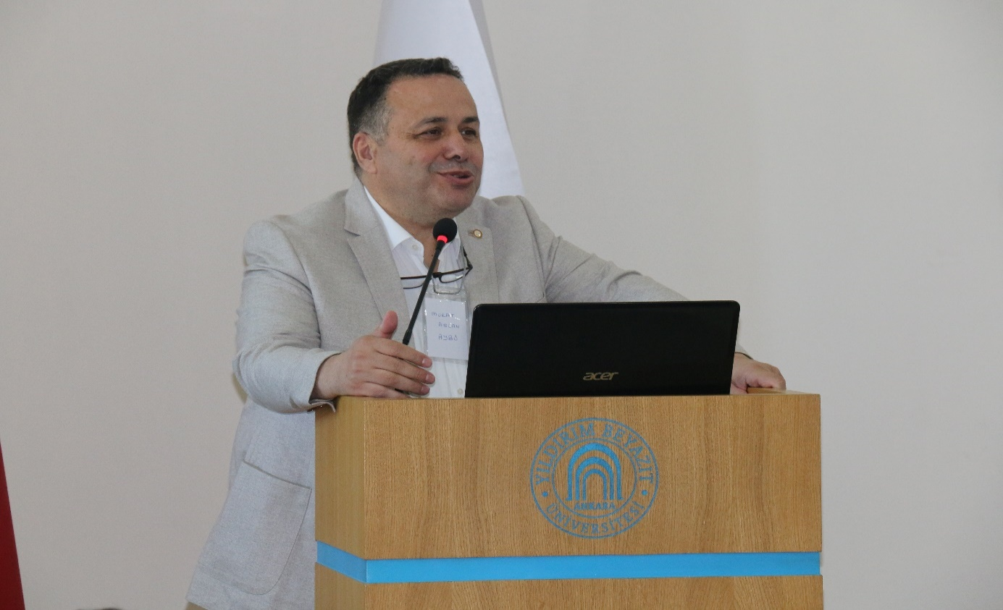
Prof. Dr. Hakkı ODABAŞ – Dean of Faculty of Political Sciences at Ankara Yıldırım Beyazıt University
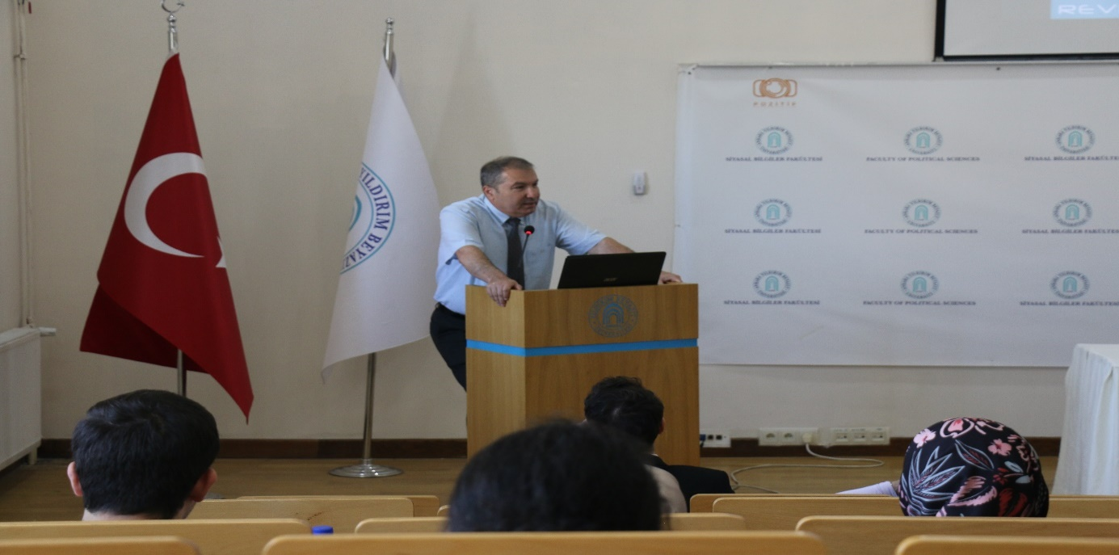
Keynote Speaker - Prof. Dr. Mehmet CANER, Thurman-Raytheon Distinguished Professor of Economics, Expert in Machine Learning-Finance, Co-Founder Magnus AI, North Caroline State University, USA
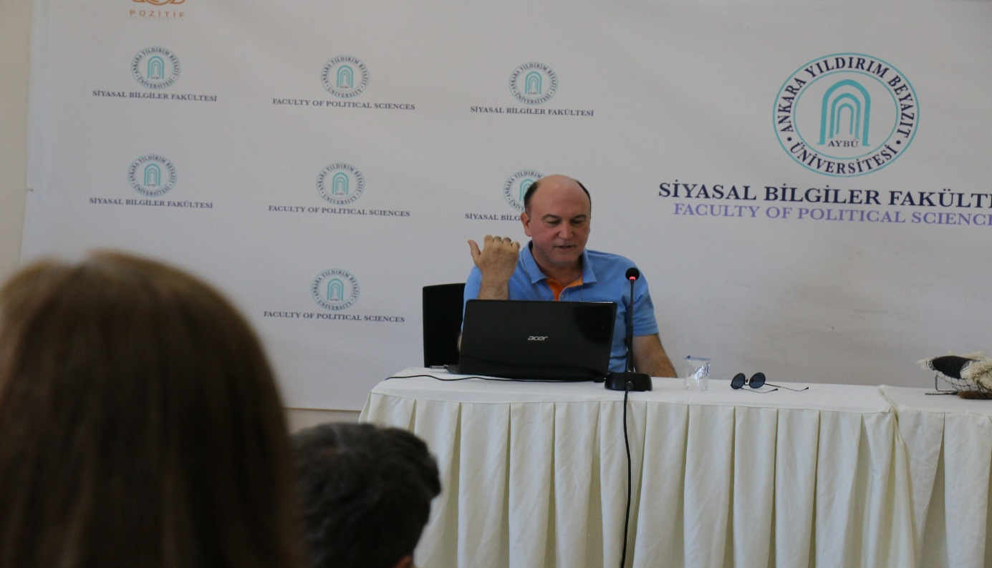

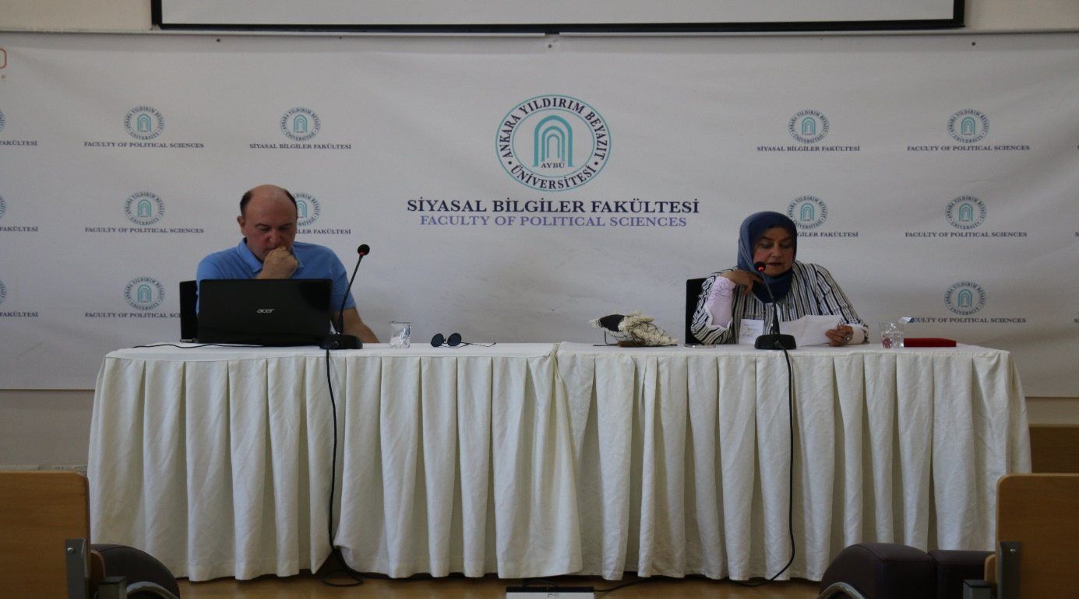
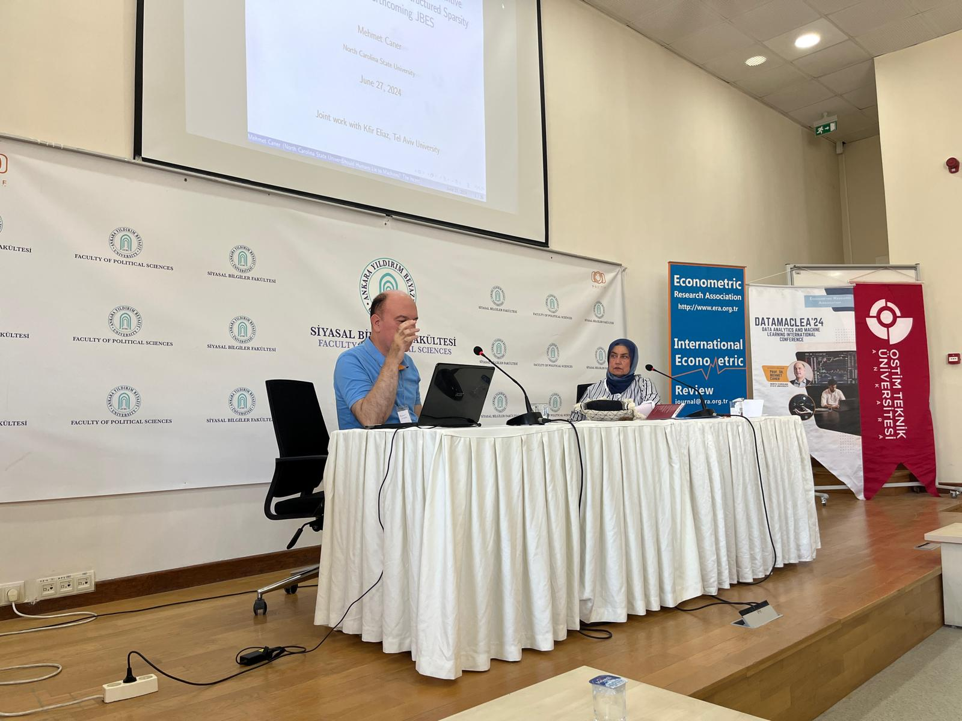

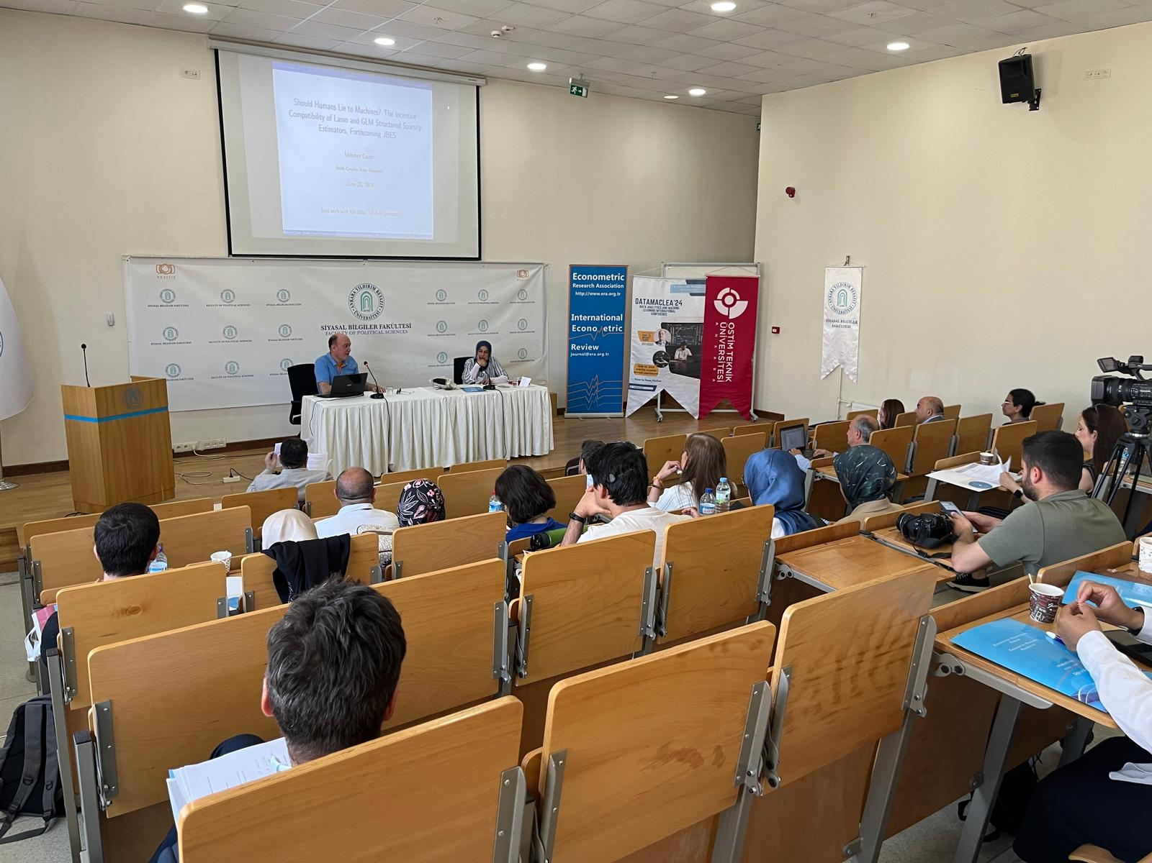
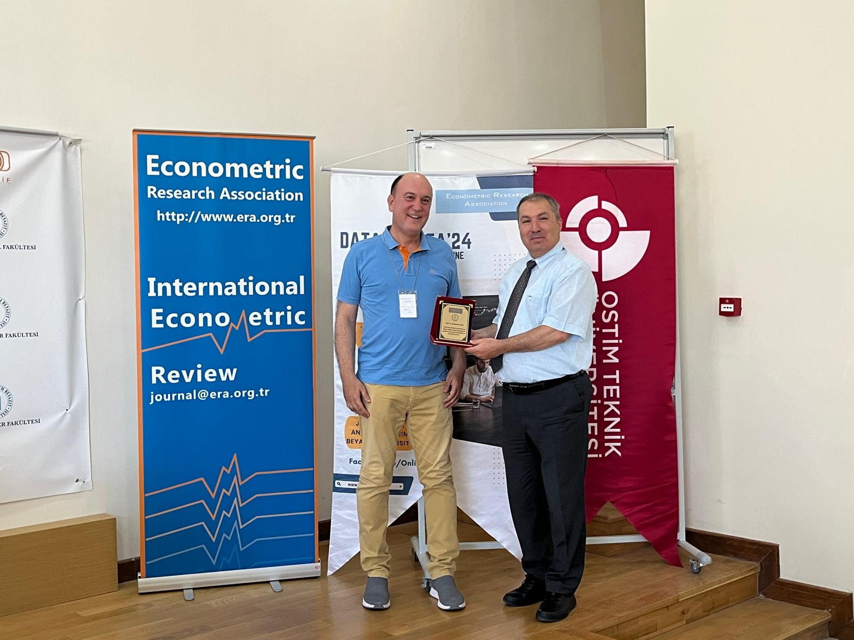
Parallel Sessions
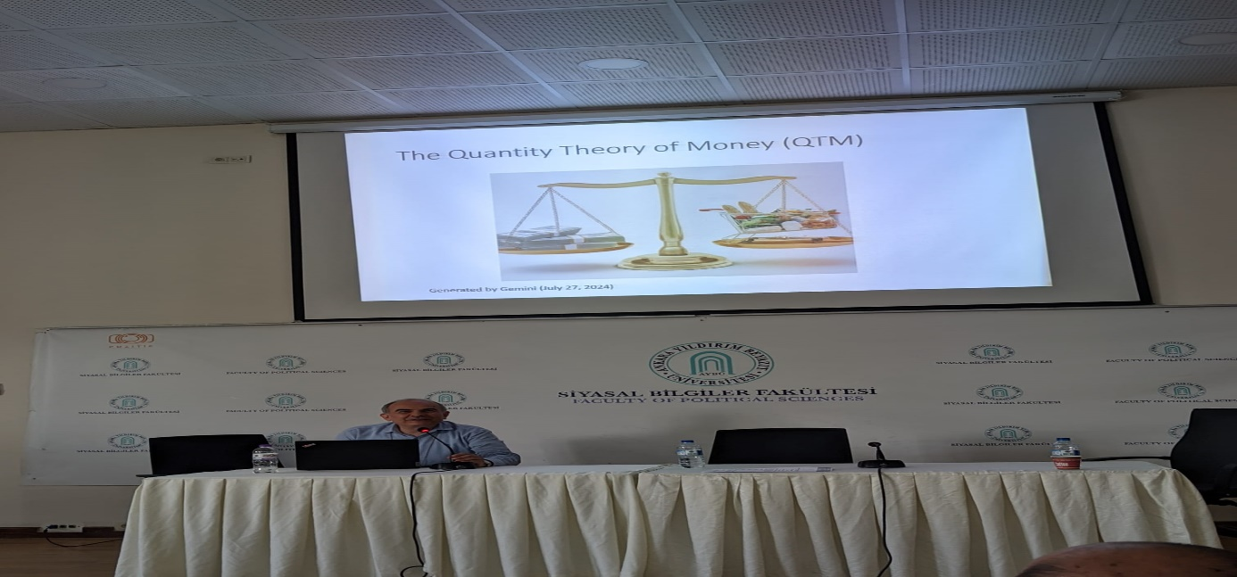
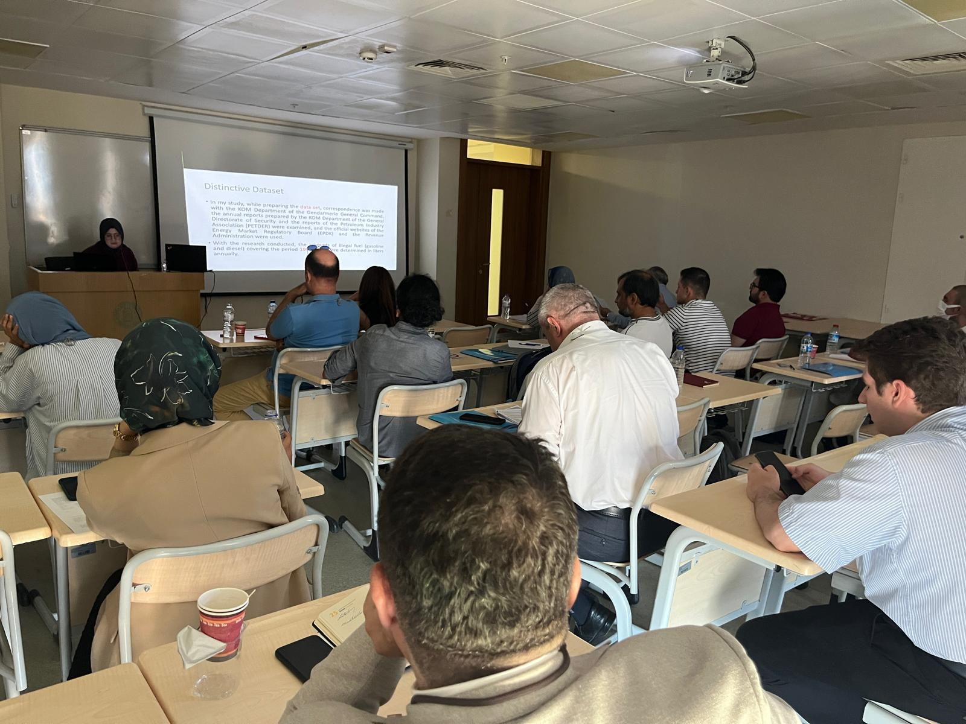
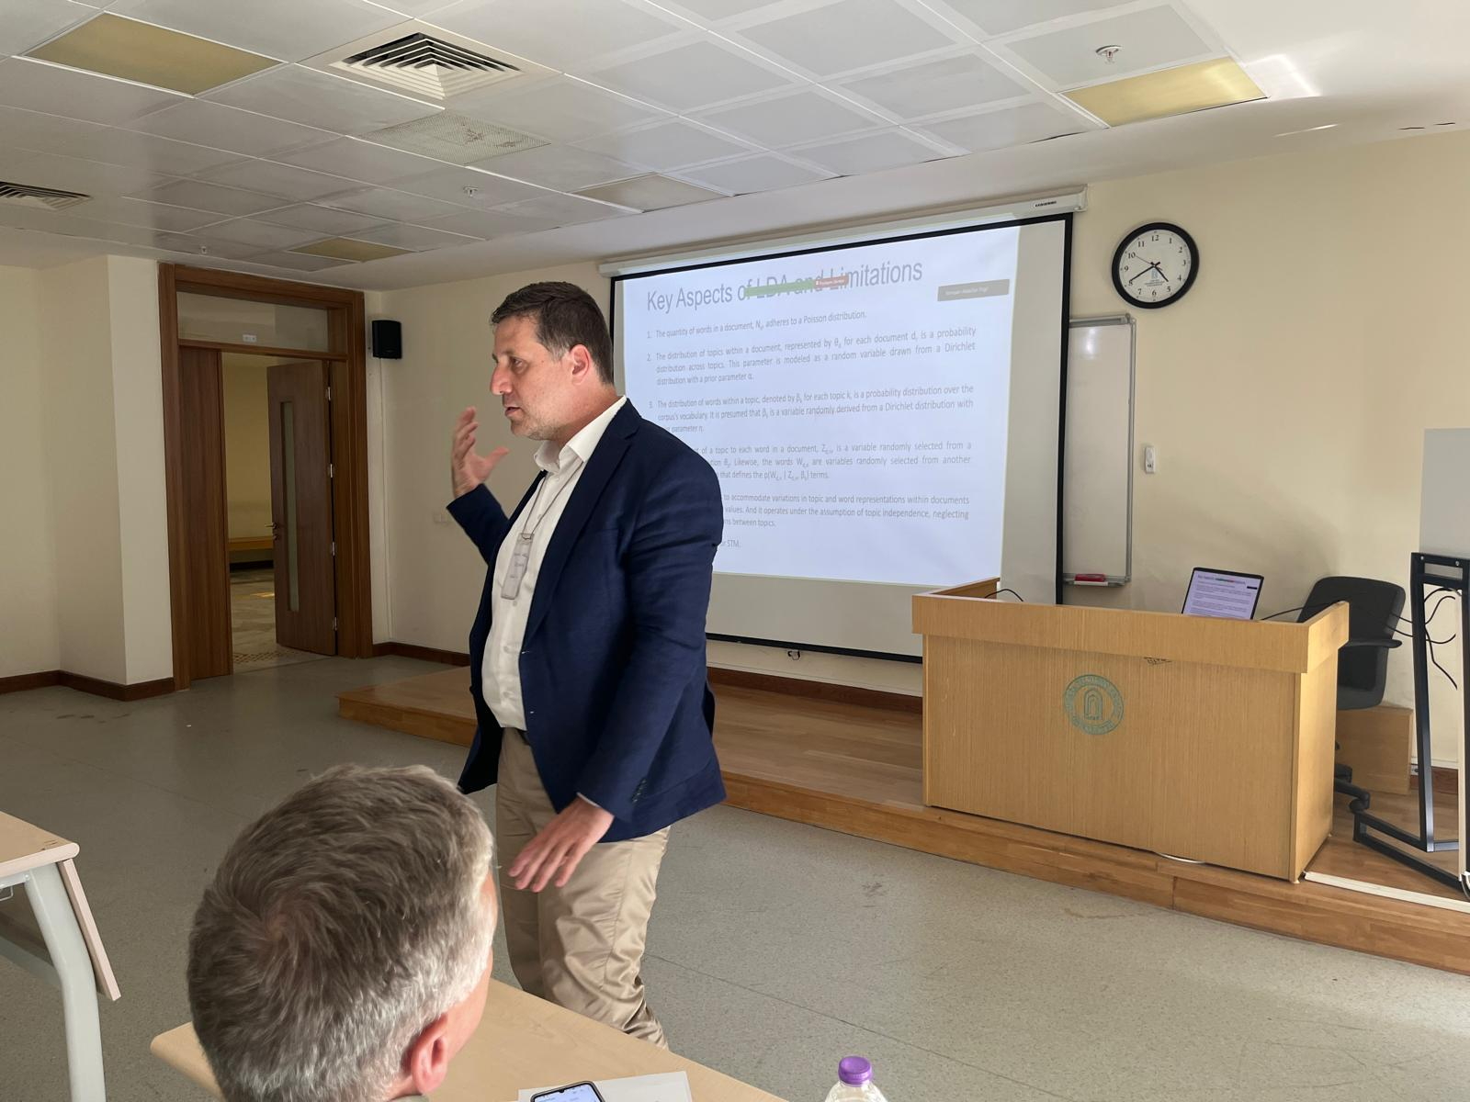
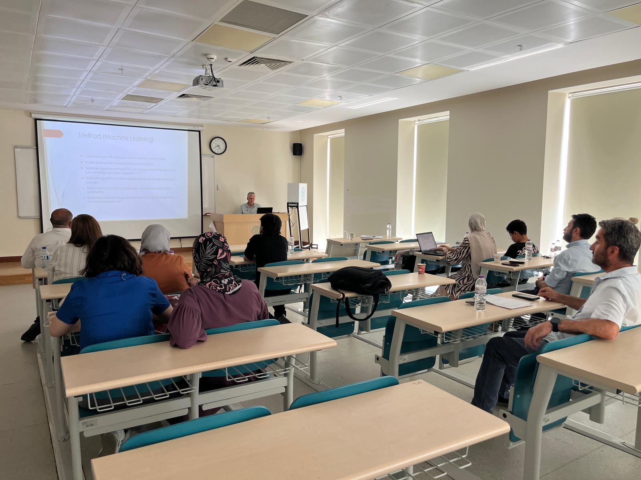
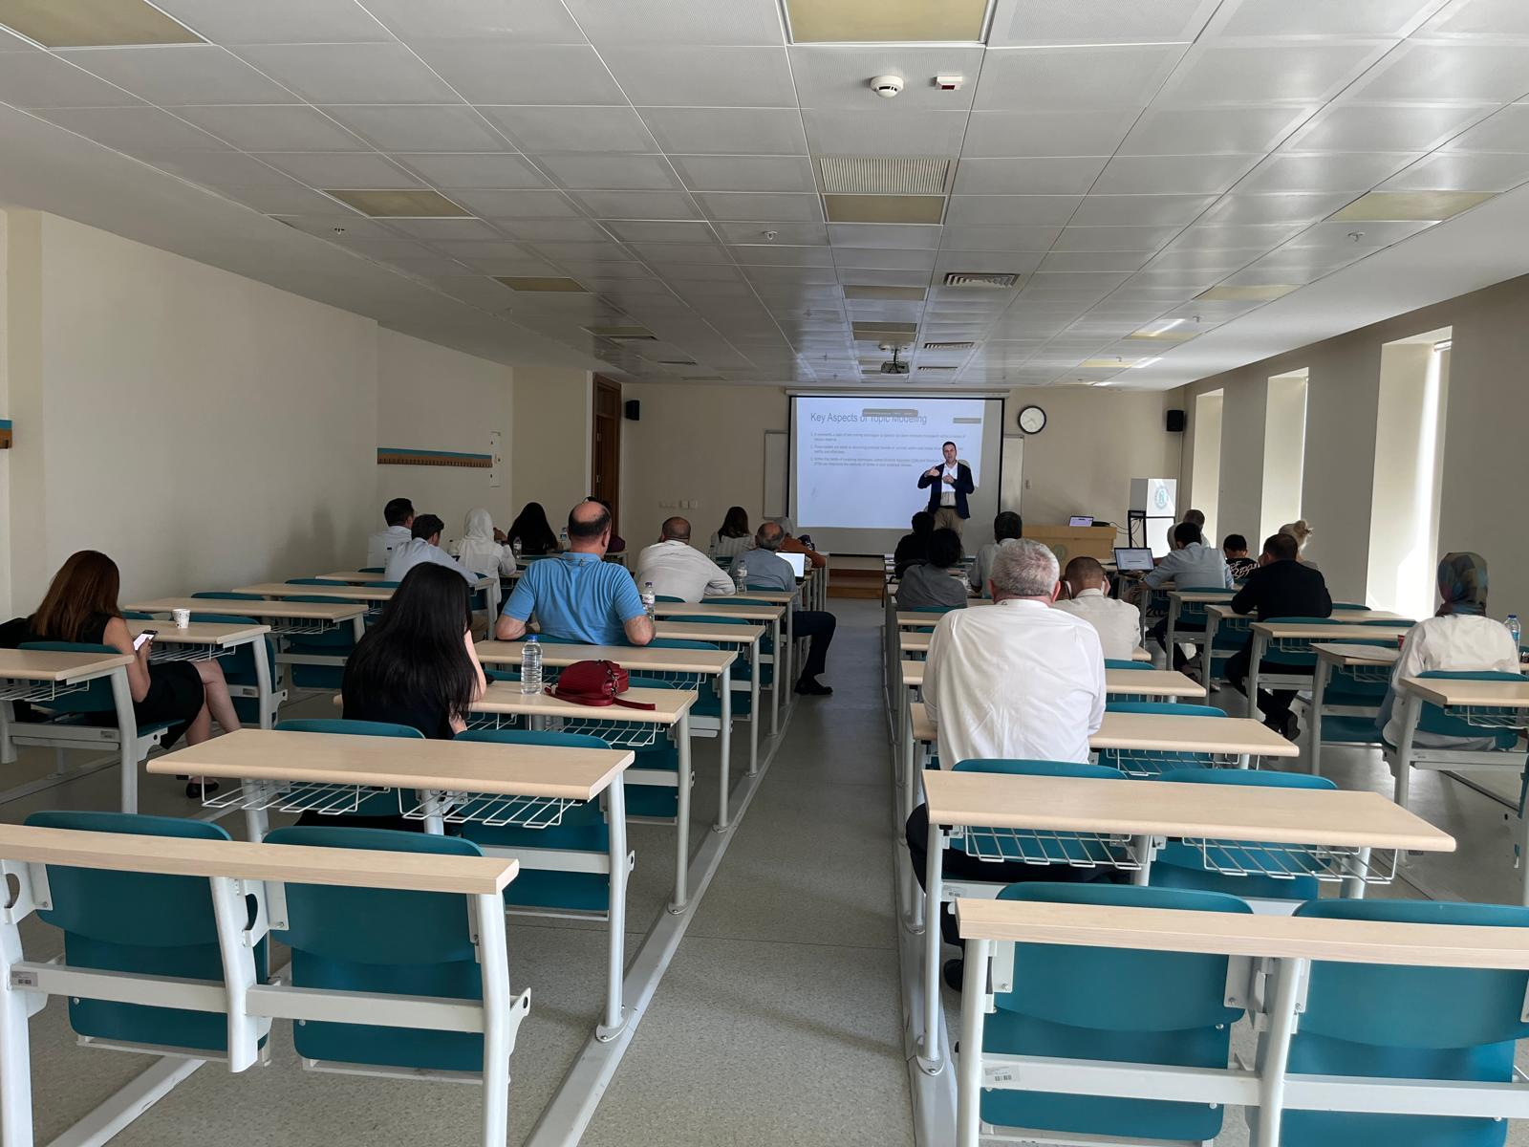
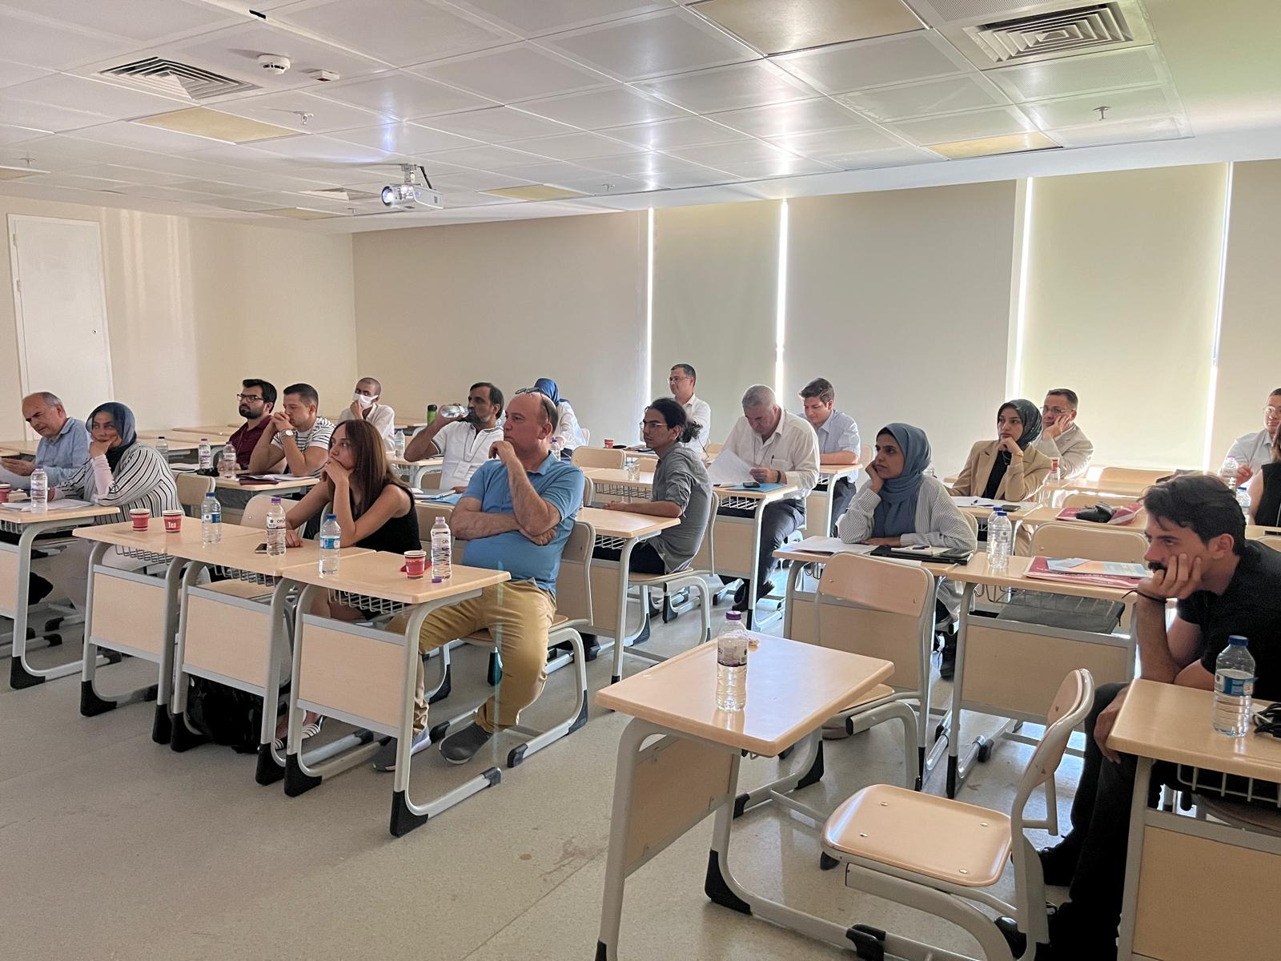

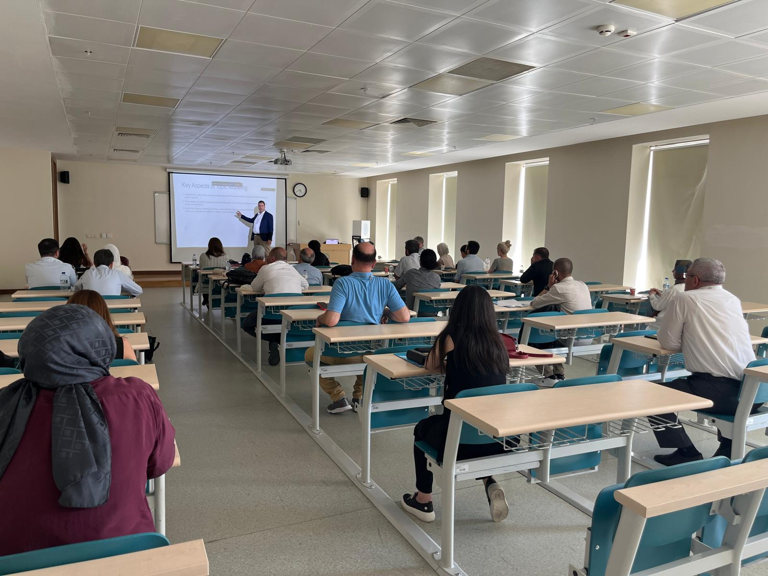
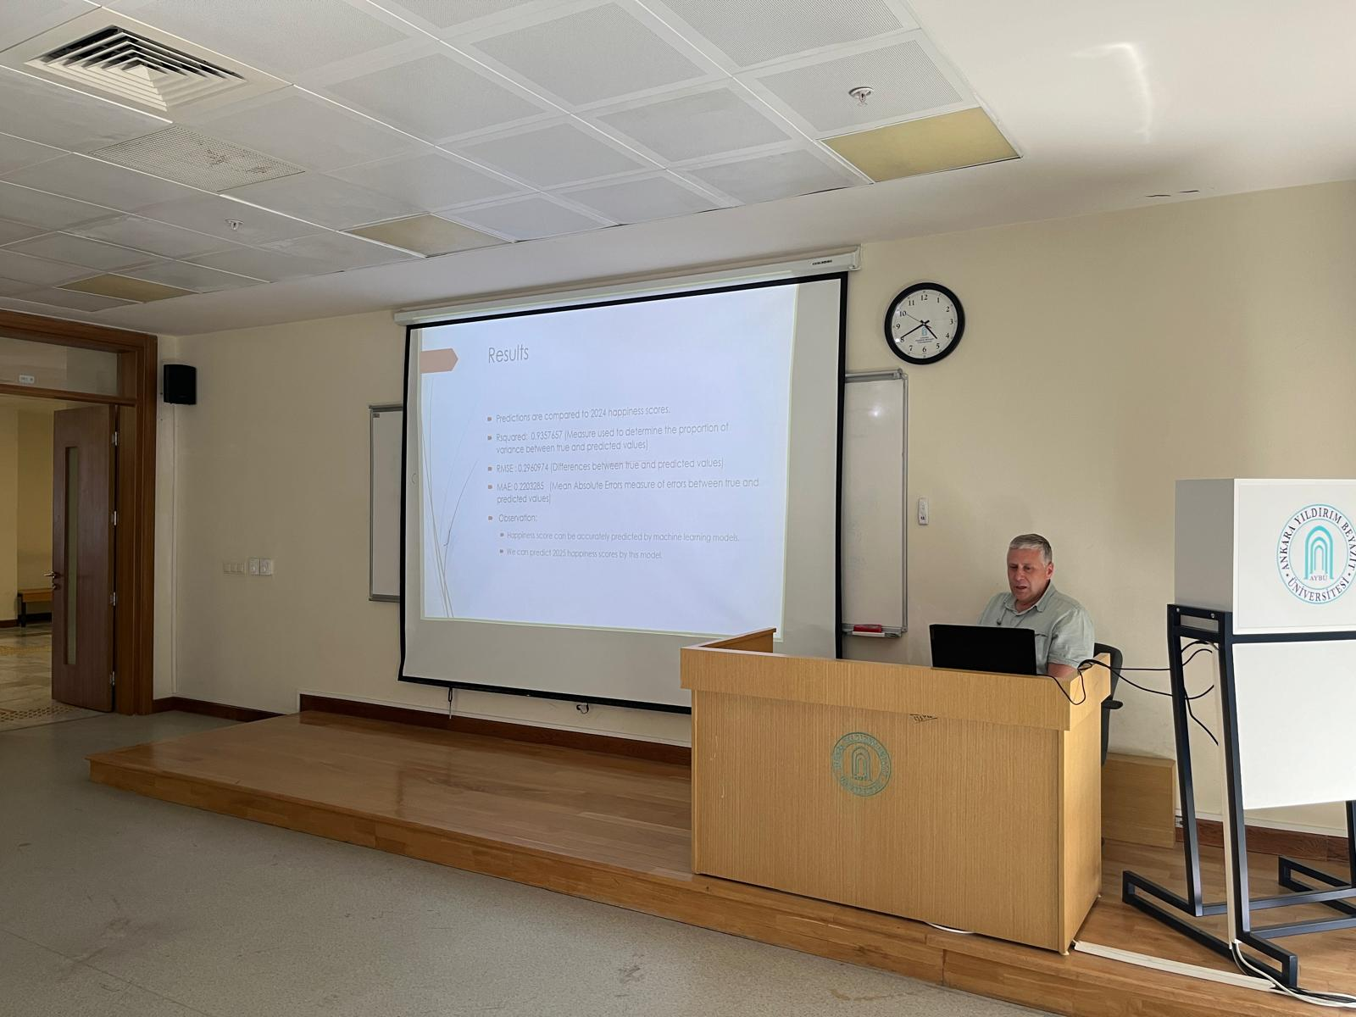

Panel – Big Data
(Moderator: Prof. Dr. Murat YÜLEK, Ostim Technical University)
Rıfat ARAS – TCMB
Esra ULAŞAN - Magnus
Assoc. Prof. Dr. Özgür Hakan AYDOĞMUŞ - Social Sciences University of Ankara
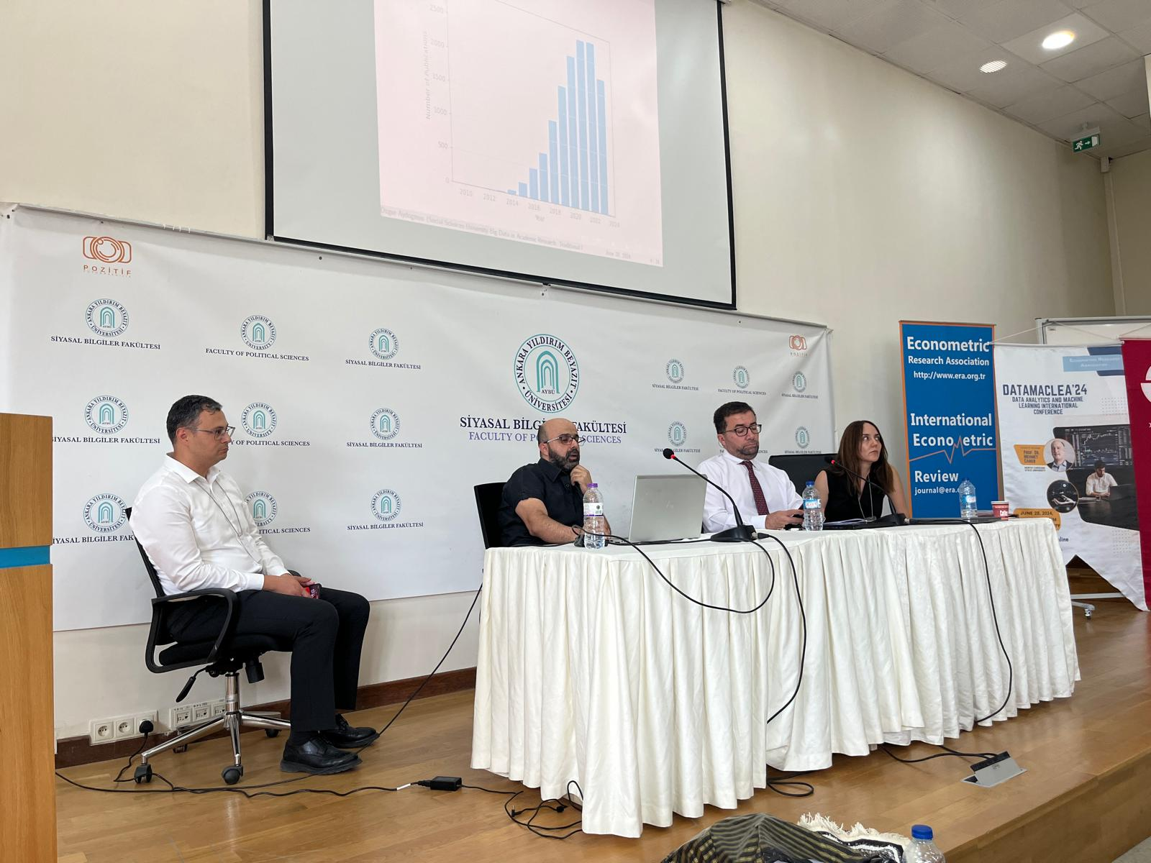
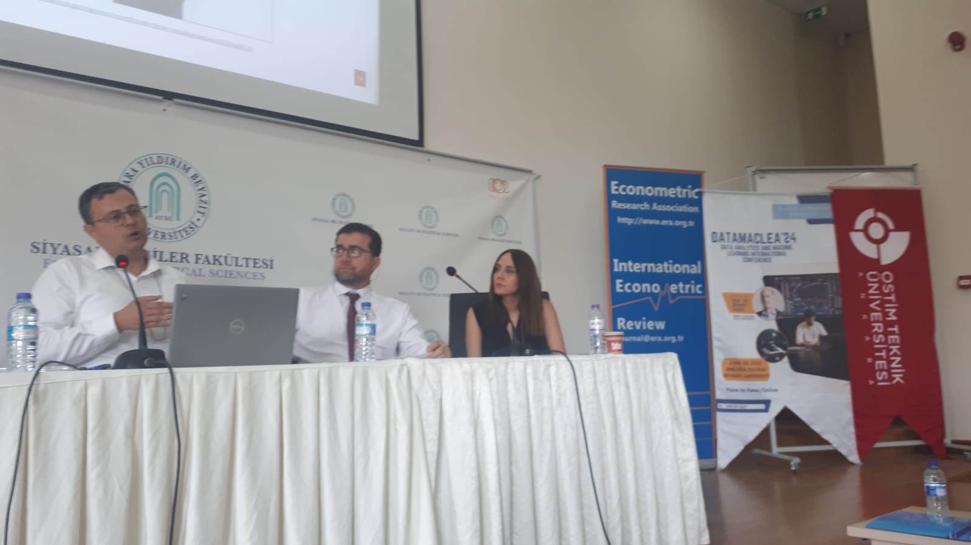
Family Photo
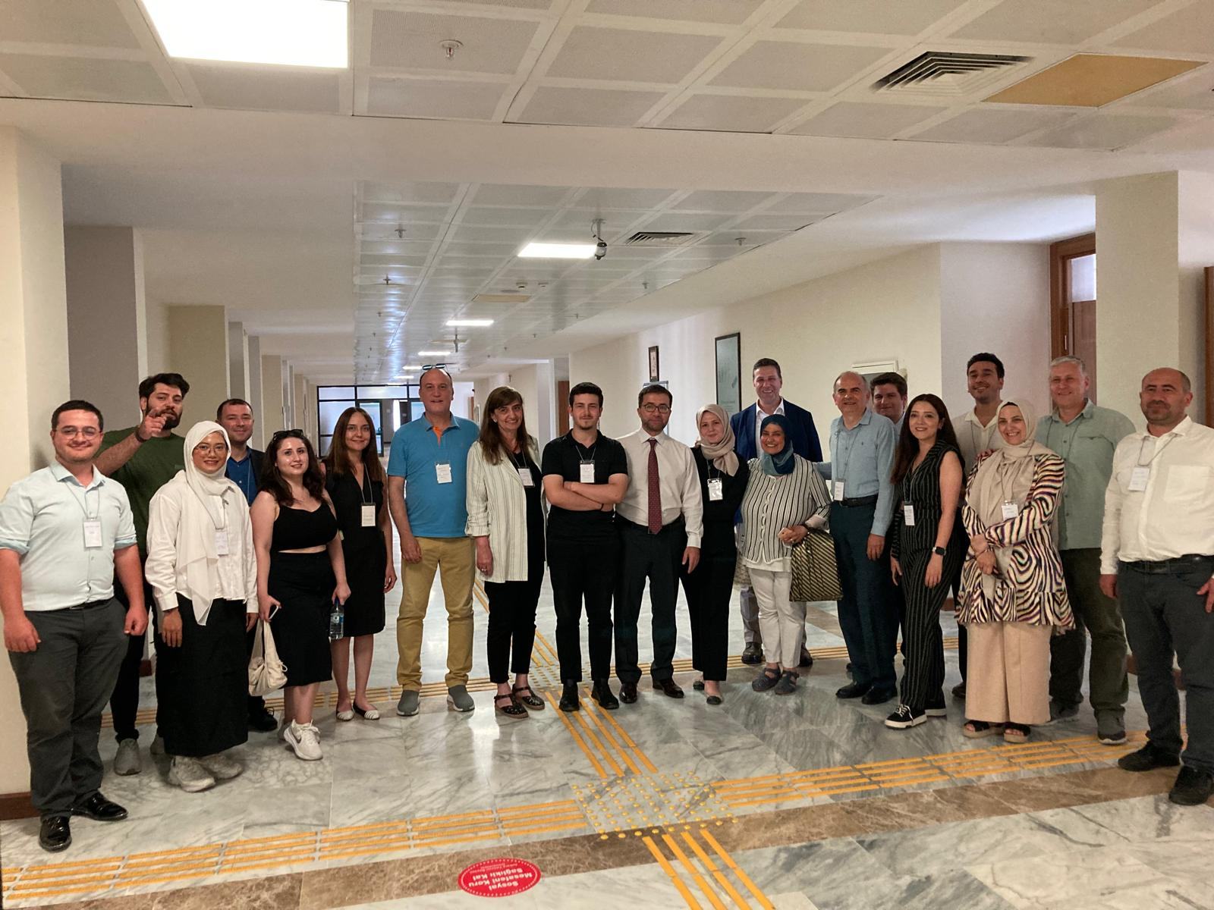
Coffee and Lunch Breaks

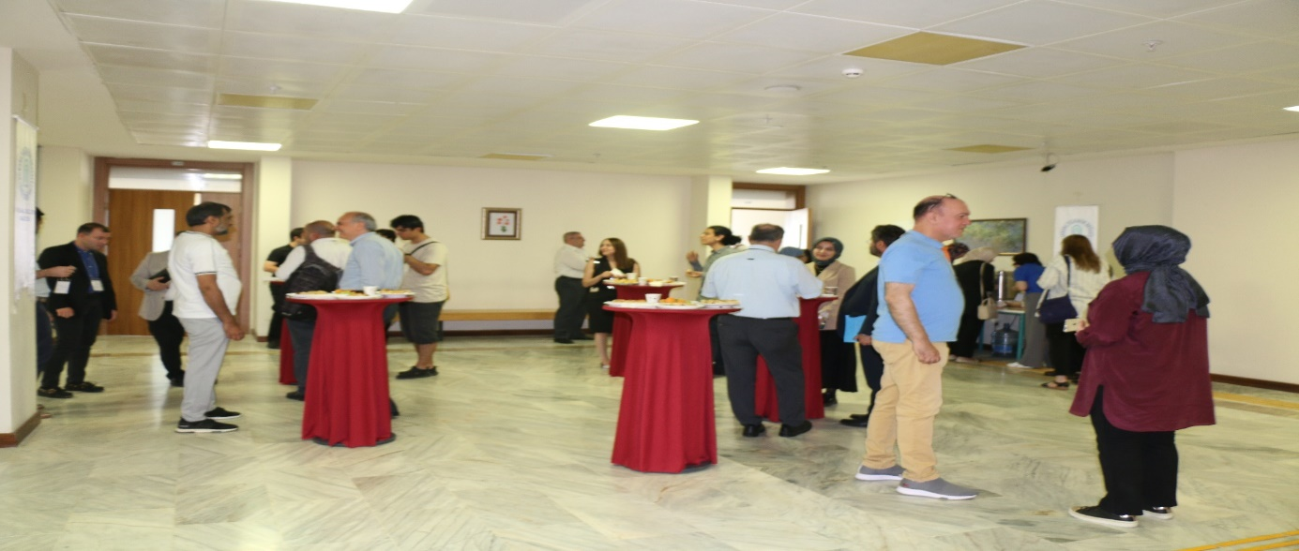
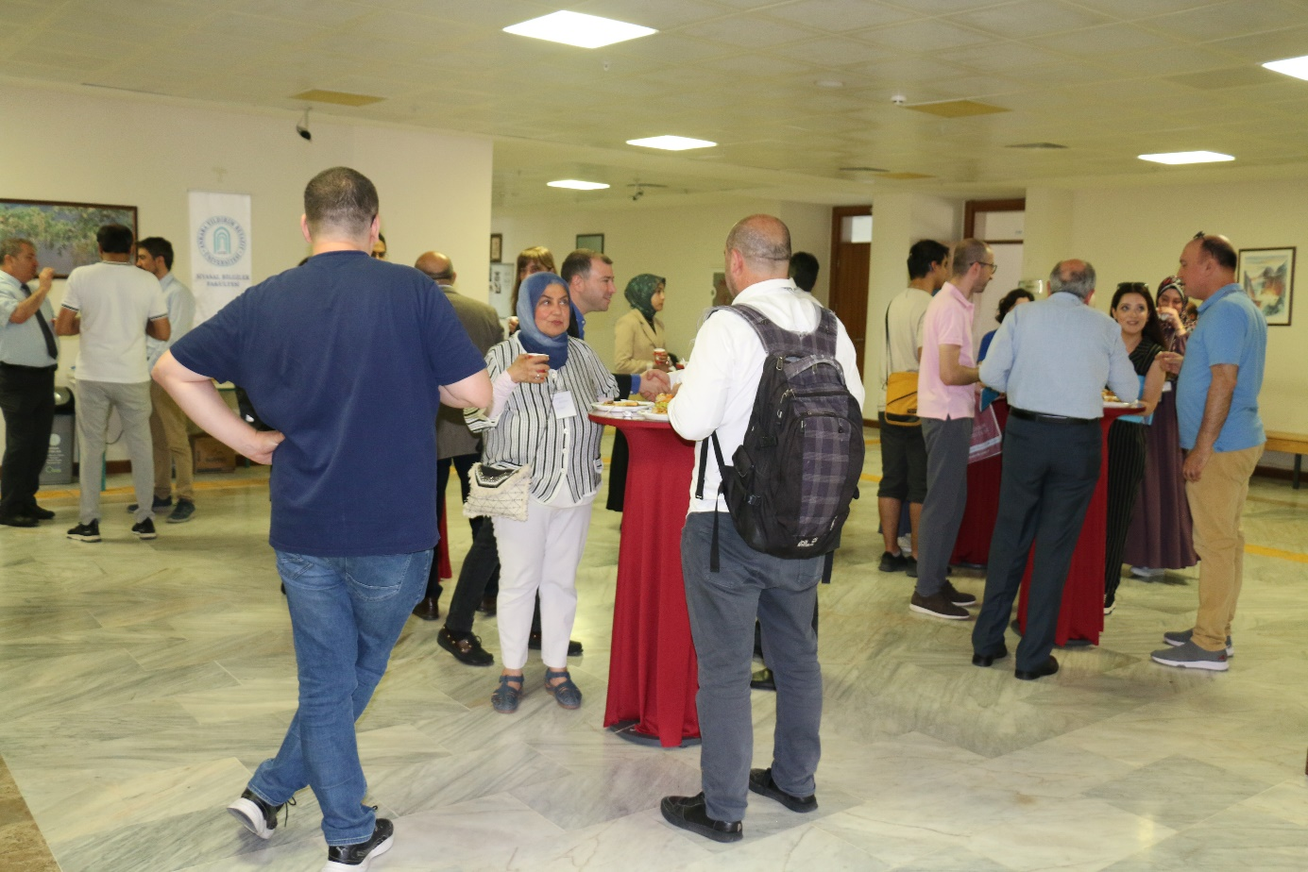
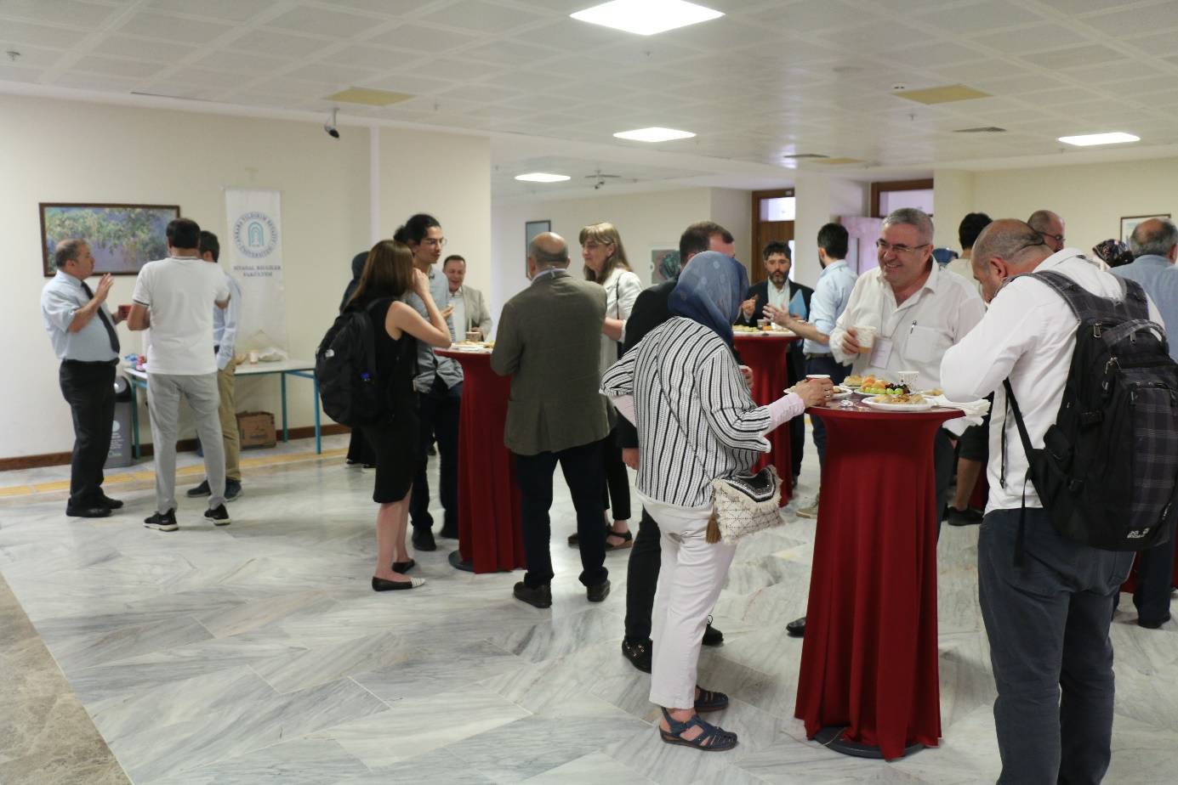
Gala Dinner
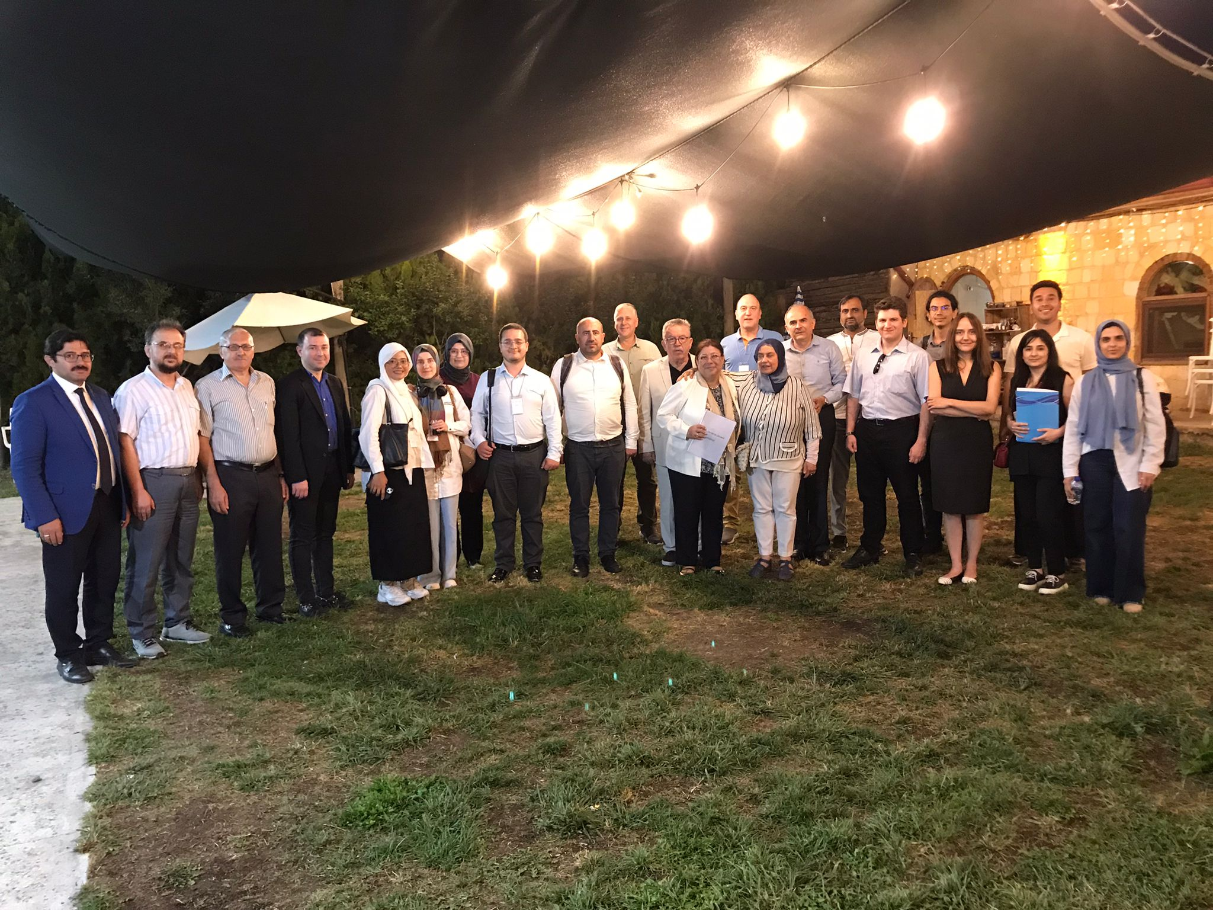
Senior and Junior Members of Econometric Research Asscociation
Prof. Dr. Kıvılcım METİN and Dr. Mert AKYÜZ
